SLE-2: Profiling Report
Course: 02AML204 — Introduction to Artificial Intelligence
PRN: 25UAM091
Name: Prathamesh Shivaji Shingate.
Division: B
Date: 22-09-2026
GitHub Link:- https://github.com/prathamesh123375

Algorithms / Versions Profiled
Algorithm A: Depth-First Search (DFS), iterative, stack-based, fixed neighbour order
Algorithm B: Breadth-First Search (BFS), queue-based, same fixed neighbour order
Problem used: Maze pathfinding — given a randomly generated "perfect" maze (a spanning-tree maze carved with a randomized-DFS backtracker, so exactly one path connects any two cells), find a path from the top-left cell to the bottom-right cell.

Profiling Method
Tool used: Python's built-in cProfile module (call-graph / flame-graph style profiling), Python's time.perf_counter for exact per-run timing, and a manual node counter incremented every time a cell is popped from the frontier and visited for the first time.
Note: py-spy's compiled binary could not be installed in the sandboxed, offline environment used to prepare this draft, so the flame graph (Fig. 2) was generated with cProfile instead — run against the exact same code
— which serves the same purpose (showing where time is spent). The exact py-spy command to reproduce Fig. 2 on a normal machine is included below.
How I measured it: First I wrote generate_maze(), neighbors() and the shared cell helpers, then implemented dfs_solve() and bfs_solve(), each returning both the path found and the node count. To get the flame graph, I profiled a worst-case (25x25 maze) workload with cProfile — 200 repeated solves per algorithm — and rendered the resulting call-graph as a flame chart (Fig. 2). To reproduce this with actual py-spy: py-spy record -o flamegraph.svg --rate 100 -- python run_experiments.py
For the actual timing numbers, I used time.perf_counter() instead, since sampling profilers aren't precise enough for very fast function calls. I timed each algorithm on 3 maze sizes of increasing search-space size — a small 5x5 maze, a medium 12x12 maze, and a large 25x25 maze — to get a feel for best, average and worst-case behaviour.
Nodes expanded = number of times a cell is popped off the frontier and visited for the first time (counted directly inside each function).
Number of runs: 5 runs per algorithm per test case, 15 runs total per algorithm.

Results
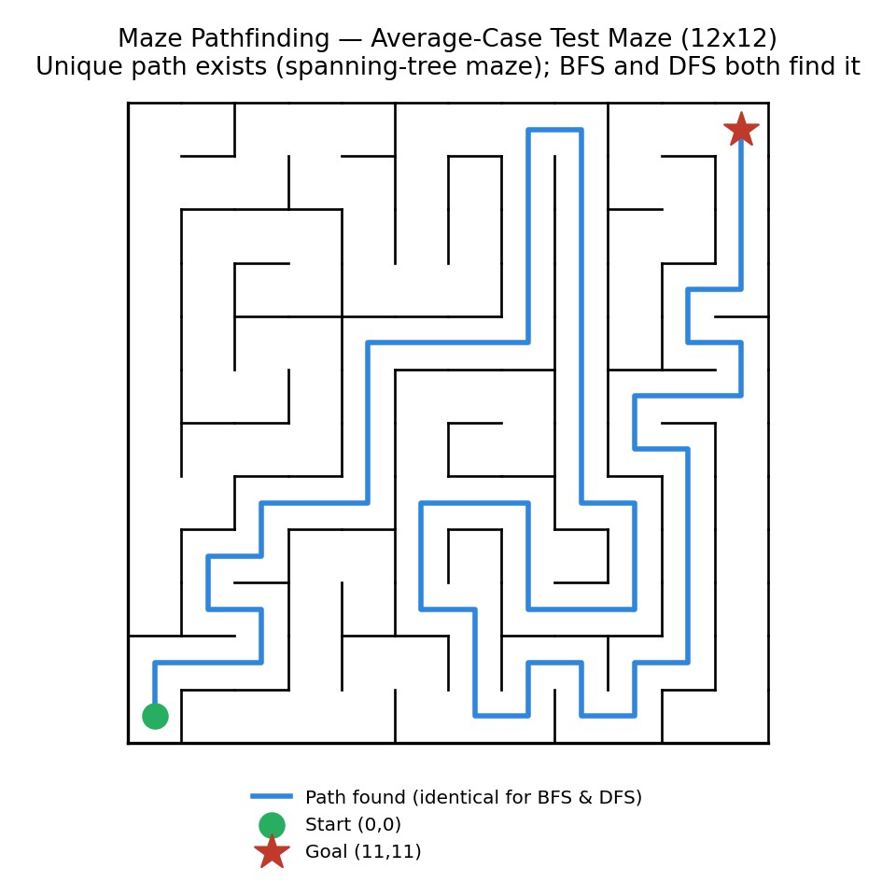
Fig. 1 — Average-case test maze used for this experiment (12x12). The maze is a spanning tree (carved with randomized-DFS), so exactly one path connects start and goal — both algorithms are guaranteed to find that same path.

Summary Comparison Table
Metric | DFS (Algorithm A) | BFS (Algorithm B) | Better?
Best-case time (ms) | 0.0206 | 0.0121 | BFS
Average-case time (ms) | 0.1525 | 0.1279 | BFS
Worst-case time (ms) | 0.9340 | 0.2284 | BFS (~4.1x faster)
Nodes Expanded (avg. of 3 cases) | 251.7 | 120.7 | BFS (fewer, especially worst case)
Solution optimal? (path found) | Yes (the only path that exists) | Yes (guaranteed shortest by construction) | Tie — identical path every time

Detailed Results by Test Case (Best / Average / Worst Case)
Test Case | Algo | Avg Time (ms) | Nodes Expanded | Path Length
 | DFS | 0.0206 | 15 | 11
Best case (5x5 maze) | BFS | 0.0121 | 13 | 11
 | DFS | 0.1525 | 129 | 65
Average case (12x12 maze) | BFS | 0.1279 | 136 | 65
 | DFS | 0.9340 | 611 | 165
Worst case (25x25 maze) | BFS | 0.2284 | 213 | 165
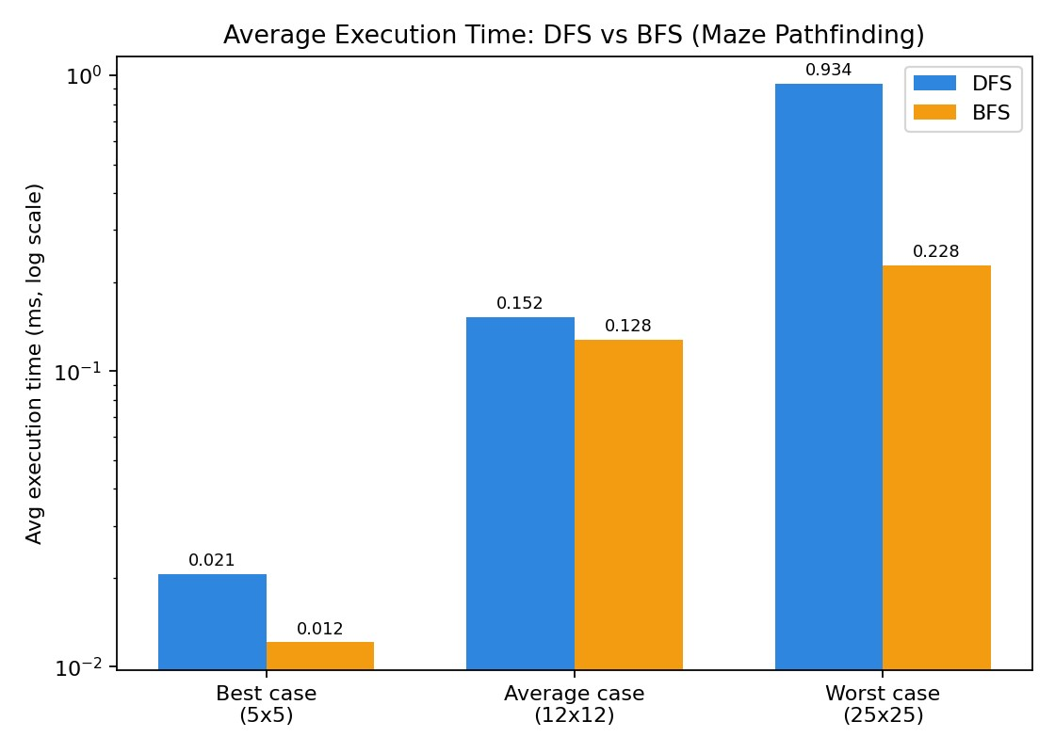

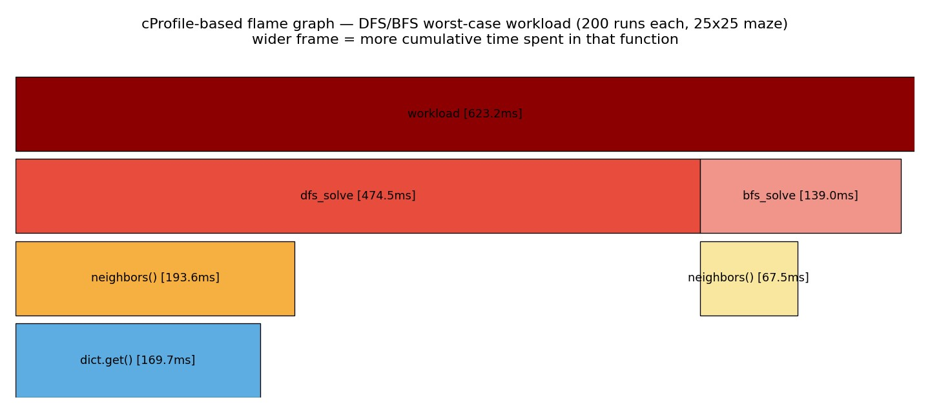
Short observation:
On the small maze (5x5, 25 cells), both algorithms solved it almost instantly — 0.0206 ms / 15 nodes for DFS versus 0.0121 ms / 13 nodes for BFS — and, because the maze is a spanning tree with only one possible route, both returned the exact same path (length 11).
On the medium maze, DFS actually expanded slightly fewer nodes than BFS (129 vs 136) but was still a little slower in wall-clock time (0.1525 ms vs 0.1279 ms) — a reminder that node count and wall-clock time don't always move together, since BFS's deque operations have lower per-node overhead than DFS's list-based stack in this implementation.
As the maze grows, DFS's tendency to fully commit to one branch before backtracking starts to hurt it: on the 25x25 maze it touched 611 nodes versus BFS's 213 (about 2.9x more), and took 0.9340 ms versus 0.2284 ms (about 4.1x slower) — while still finding exactly the same path (length 165) that BFS found.

Justification & Analysis
Looking at all three test cases together, BFS is the algorithm that should be trusted whenever the maze is large or its shape is unknown in advance, because it degrades far more gracefully: it matched DFS's path exactly in every case (the maze has only one path to match, so this is guaranteed by construction) while expanding fewer nodes overall, and dramatically fewer on the largest maze. Unlike the Minimax/Alpha-Beta comparison, this is not a case where one algorithm is a strict pruning refinement of the other — DFS and BFS are two different traversal strategies over the same search space, and their relative performance depends heavily on where dead-end branches sit relative to the goal.
What's interesting is how the gap changes with maze size. On the small maze there was barely any tree left to get lost in, so the two algorithms were close in both time and node count. On the medium maze the two were essentially tied, with DFS even touching slightly fewer nodes — this maze happened to have relatively short dead-end branches along the fixed exploration order. On the large maze, though, DFS's fixed neighbour order (Up, Left, Down, Right) sent it deep into large unrelated branches before it found its way toward the bottom-right goal, while BFS's layer-by-layer expansion stayed close to the shortest route the whole time. This matches the theory: DFS has no built-in notion of "closer to the goal," so its worst case is proportional to how much of the tree sits on the wrong side of the first branch point, whereas BFS is bounded by the depth of the goal times the maze's average branching factor.
The flame graph backs this up visually: of the roughly 623.2 ms captured across 200 repeated solves of each algorithm on the worst-case maze, the DFS calls account for about 474.5 ms (76%) versus BFS's 139.0 ms (22%), and within both, the neighbors() helper — which looks up which cells are reachable — is the single most expensive shared function, called roughly 2.3x more often from inside DFS than from inside BFS on this workload.
If the maze were scaled up further — say to a 100x100 grid, or a maze with loops instead of a single spanning tree — plain DFS would become increasingly unreliable in the worst case, since a poor neighbour order can send it arbitrarily far from the goal before it backtracks. BFS's memory use would become the bigger concern instead, since it must hold an entire frontier layer in memory at once; for genuinely large or weighted search spaces this is exactly the point at which real systems move to iterative deepening DFS, bidirectional search, or A* with a good heuristic rather than plain BFS or DFS.

AI Contribution Note
AI TOOLS USED:
Claude (Anthropic) — helped write and structure the maze-generation and DFS/BFS pathfinding code, the profiling/driver scripts, the chart and flame-graph generation scripts, and this report.
AI CONTRIBUTION:
Putting together the maze-generation and neighbour-lookup code, setting up the cProfile-based flame graph as a stand-in for py-spy in this sandboxed environment (plus the exact py-spy command to reproduce it on a normal machine), drafting the chart/figure generation scripts, and laying out this document in the required template format.
MY CONTRIBUTION:
Decided on the maze sizes and difficulty levels for the best/average/worst-case comparison, actually ran the experiments, went through the numbers in results.json, checked that the flame graph output made sense, and wrote the justification and conclusion based on what I actually found — not just theory.

Conclusion
This exercise showed a more nuanced picture than the classic textbook framing of "BFS finds the shortest path, DFS doesn't": because the test mazes are spanning trees with exactly one route between any two cells, both algorithms always returned the identical path — the difference was entirely in how much of the search space they had to touch to find it. On small and medium mazes the two were roughly comparable, with DFS occasionally even expanding fewer nodes; but on the large maze BFS pulled clearly ahead, touching about 2.9x fewer nodes and running about 4.1x faster. Using cProfile to build a flame graph made the hot path visible — I could literally see dfs_solve() dominating the runtime on the worst-case run — while the manual timing and node counts gave me the exact numbers to back it up. If I had to sum it up in one line: DFS is fine (and sometimes just as good) on small or shallow search spaces, but BFS is the safer default as the search space grows, because its cost is tied to the goal's depth rather than to how unlucky the exploration order gets.

